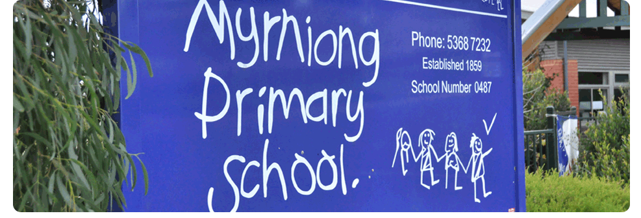
Duty Of Care

POLICY - 2017

MYRNIONG PRIMARY SCHOOL

Rationale:

In addition to their professional obligations, the staff at Myrniong Primary School have a legal duty to take reasonable steps to protect students in their charge from risks of injury that are reasonably foreseeable.

Aims:

- To ensure Myrniong Primary School staff have an understanding of their duty of care to students and other employees or volunteers, and behave in a manner that does not compromise these legal obligations.

Implementation:

- In addition to their professional obligations, staff have a legal duty to take reasonable steps to protect students in their charge from risks of injury that are reasonably foreseeable.
- Although the general duty is to take reasonable steps to protect students from reasonably foreseeable risks of injury, specific (but not exhaustive) requirements of the duty involve providing adequate supervision in the school or on school activities as well as providing safe and suitable buildings, grounds and equipment.
- A teacher’s duty of care is not confirmed to the geographic area of Myrniong Primary School or to school activities, or to activities occurring outside the school where a student is activng on a teacher’s instructions. The duty also applies to situations both before and after school where a teacher can be deemed to have ‘assumed’ the teacher-students relationship.
- The teacher’s duty of care is greater than that of the ordinary citizen in that a teacher is obliged to protect a student from reasonably foreseeable harm or to assist an injured student, while the ordinary citizen does not have a legal obligation to respond.
- Whilst each case regarding a teacher’s legal duty of care will be judged on the circumstances that occurred at the time, the following common examaples may be times when a teacher has failed to meet their legal duty of care responsibilities to their students –
- Arriving late to scheduled timetabled yard duty responsibilities
- Failing to act appropriately to protect a student who claims to be bullied
- Believing that a child is being abused but failing to report the matter appropriately
- Being late to supervise the line up of students after the bell has sounded
- Leaving students unattended in the classroom
- Failing to instruct a student who is not wearing a hat to play in the shade
- Ignoring dangerous play
- Leaving the school during time-release without approval
- Inadequate supervision on a school excursion
- Staff members are also cautioned against giving advice on matters that they are not professionally competent to give (negligent advice). Advice is to be limited to areas within a teacher’s own professional competence and given in situations arising from a role specified for them by the Principal.
- Teachers must ensure that the advice they give is correct and where appropriate, in line with the most recent available statements from institutions or employers. Teachers should not give advice in areas outside those related to their role where they may lack expertise.

Evaluation:

- This policy will be reviewed as part of the school’s three-year review cycle.

