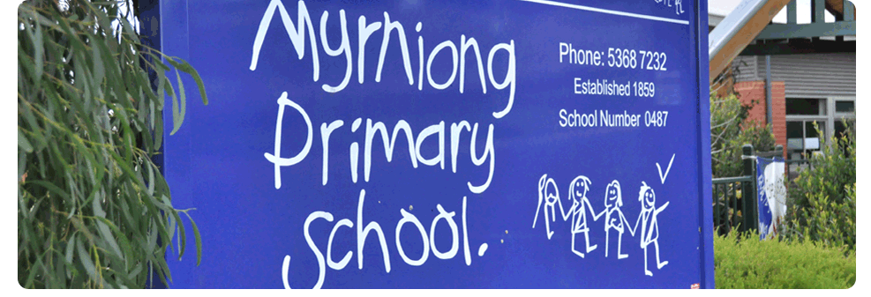
HOMEWORK

POLICY 2017

MYRNIONG PRIMARY SCHOOL

Rationale:
Myrniong Primary School believes that homework plays an important role in the academic and personal development of students from Prep to Year 6. It provides an opportunity for parents, teachers and students to share the responsibility for encouraging the view that learning occurs beyond school and can be actively pursued at home.

Aims:
The purpose of Homework at Myrniong Primary School is –
- To enable students to reinforce and develop curriculum skills and attitudes learnt at school.
- To provide parents with an involvement in their child’s education.
- To foster and develop good study habits and provide an opportunity for students to be responsible for their own learning.

Implementation:
Homework should:
- Be related to work being covered in class, not to introduce new concepts.
- Cover a wide range and variety of activities, which are interesting and challenging.
- Be able to be completed by the child with minimal parent assistance and within a reasonable time.
- Be able to be completed without substantial educational resources at home. Teachers may need to assist in providing resources when required.
- Have a clearly defined purpose that is understood by the child and parent.
- Be assessed with feedback and support provided by teachers.
- Not impinge on the time needed for other activities such as music, clubs or sport nor should it impinge on quality teaching time.
- The Homework Policy is made available throughout the year via the school’s website and at the office.
- Homework expectations for the year will be outlined at the first Parent Information Session / Interview.
- ILP work as per ILP
- Each Year Level will develop a set of follow up processes for homework not completed
- The homework policy will be included as part of the Prep Information Pack and new enrolment information packs
Homework will mainly consist of:

Years Prep - 2
- Reading activities to, with and by parents, recorded in students’ reading logs / Diaries.
- Spelling practice
- Simple extension tasks associated with classroom activities.
Homework will generally not exceed 20 minutes per day.
Years 3 - 6
- Home reading on a daily basis.
- Spelling practice
- Tasks such as continuation of classroom work, research, projects and assignments.
Homework will generally not exceed 30 minutes per day and must be co-ordinated between teachers to avoid excessive workload.

Evaluation:
This policy will be reviewed as part of the school’s three-year review cycle.

