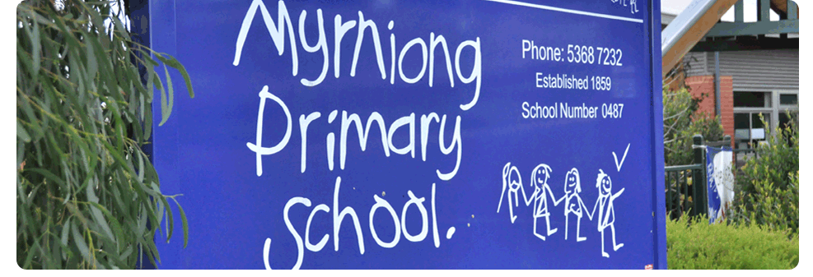
Parent Complaints

POLICY 2017

MYRNIONG PRIMARY SCHOOL

Rationale:
At times parents may have concerns they wish to take up with the school. Myrniong Primary School welcomes this feedback and encourages parents to raise issues so they can be dealt with speedily and resolved to the satisfaction of all concerned.
Aims :
- To assist staff to confidently address the complaints of parents
- To ensure a balance between the rights of all parties involved
- To ensure both that parents will have a clear process to follow and that complaints are dealt with promptly and fairly.
Concerns and Complaints covered by the procedures
These procedures cover concerns and complaints about:
- Incidents of bullying or harassment in the classroom or the school yard;
- General issues of student behaviour that are contrary to Myrniong Primary School’s student engagement guidelines
- Learning programs, assessment and reporting of student learning;
- Communication with parents;
- School fees and payments;
- General administrative issues;
- Any other school-related matters except as detailed below.
Matters not covered by this policy and procedures, for which there are existing rights of review or appeal include:
Those matters include:
- Student discipline matters involving expulsions;
- Complaints about employee conduct or performance and complaints that should be dealt with by performance management, grievance resolution or disciplinary action;
- Complaints by the Departments employees related to their employment;
- Student critical incident matters;
- Other criminal matters.
The Principal or Regional Office can advise about specific procedures for complaints of these types
Expectations
Myrniong Primary School expects a person raising a concern or complaint to:
- Do so promptly, as soon as possible after the issue occurs;
- Provide complete and factual information about the concern or complaint, preferably in writing;
- Maintain and respect the privacy and confidentiality of all parties;
- Acknowledge that a common goal is to achieve an outcome acceptable to all parties;
- Act in good faith, and in a calm and courteous manner;
- Show respect and understanding of each other’s point of view and value difference, rather than judge and blame;
- Recognise that all parties have rights and responsibilities, which must be balanced.
Myrniong Primary School will address any concerns and complaints received from parents:
- Courteously;
- Efficiently;
- Fairly;
- Promptly, or within the timeline agreed with the person with the concern or complaint;
- In accordance with due process, principals of natural justice and the Department of Education and Early Childhood Development’s regulatory framework
Raising Concerns or Complaints
In the first instance, a complaint should be made to the school. The complainant should telephone, visit and/or write to:
- The student’s teacher about learning issues and incidents that happened in their class or group;
- The Assistant Principal, if students from several classes are involved;
- The Principal about issues relating to school policy, school management, staff members or very complex student issues.
Help with raising concerns or complaints
- Personal support is most appropriate in situations where the complainant and others involved in the complaint process have emotional issues related to the complaint.
- Complainants can seek the services of an advocate when they feel they are unable to express their concern clearly. An advocate can be a friend or someone who is available through an appropriate support organisation who does not receive a fee for service.
- All parties involved in addressing a complaint may seek the services of a mediator when there is difficulty coming to an agreement.
- The school will ensure that the complainant is aware of these supports. A complainant who wishes to use these support services should ensure the person addressing the concern or complaint is aware of their intention and is in agreement.
Managing parent concerns and complaints information
When the complaint is easily resolved in a telephone call, a brief note in the school’s/principal’s/teacher’s diary recording the issue and the resolution may be all that is required. However with more complex/serious complaints the following details will be recorded:
- Name and contact details of the person with a concern or complaint;
- The date the concern was expressed or complaint made;
- The form in which the concern or complaint was received (such as face-to-face, by telephone, in writing, by email);
- A brief description of the concern or complaint;
- Any recommendations for future improvement in the school’s policy or procedures.

Addressing concerns or complaints
A parent can raise a complaint about any aspect of the school’s operations. Myrniong Primary School will make every effort to resolve concerns and complaints before involving other levels of the Department of Education and Early Childhood Development.
- Myrniong Primary School will make every attempt to resolve a concern or complaint as quickly as possible.
- Myrniong Primary School will give a complainant a copy of its complaints procedures.
- Myrniong Primary School will determine whether a concern or complaint should be managed through the school’s concerns and complaints process or through other complaints processes of the Department of Education and Early Childhood Development.
- All complaints will be noted and acted on promptly by the staff member who receives the complaint.
- Upon thorough investigation, further discussion and clarification with all parties involved, the Principal, Leading Teacher or delegate will provide a response to the complainant.
- Concerns and complaints about general school matters (such as the timing of events, school policies and facilities) will be addressed by the Principal or a relevant staff member.
If a complaint involves many students and a range of issues, the school will need more time to investigate and resolve it.
Should the complaint involve complex issues, Myrniong Primary School might need to take advice from the Department of Education and Early Childhood Development’s Regional Office, which may take more time. The school will tell the complainant the new timeline for addressing the complaint and the reasons for any delays. In all cases, the school will try to resolve a concern or complaint within twenty days.
Possible Resolutions
If a concern or complaint is substantiated in whole or part, Myrniong Primary School will offer an appropriate remedy. For example, at its discretion and depending on the circumstances, the school might offer:
- An explanation or further information about the issue;
- Mediation, counselling or other support;
- An apology, expression of regret or admission of fault;
- To change its decision;
- To change its policies, procedures or practices;
- To cancel a debt (such as for school payments);
- A fee refund.
The school will implement the remedy as soon as practicable.
Referral of concerns or complaints
If a person with a concern or complaint is not satisfied with the outcome determined by the school, they should contact the Department of Education and Early Childhood Development’s appropriate regional office. The officer from the region will ask the complainant for a complete and factual account in writing of the concern or complaint and the complainant’s opinion about why the school did not resolve it to their satisfaction.
If the complaint cannot be resolved by the complainant, school and regional office working together, the regional office may refer it to the Department’s Group Coordination Division. The Division will ask the complainant for a complete and factual account in writing of the concern or complaint and complainant’s opinion about why the school and regional office did not resolve it to their satisfaction and will ask the complainant to outline their view on the course of action required to resolve the complaint. Where the complainant is unable to provide a written account the officer from Group Coordination Division should act on the information provided.
Communication and training
Myrniong Primary School’s procedures for addressing concerns and complaints will be:
- Published on the school’s website;
- Given to a parent when their child enrols;
- Printed in the Parent Information Book;
- Printed in the school newsletter.
Myrniong Primary school will:
- Brief all members of staff (including volunteers) about its procedures to address concerns and complaints.
- Provide staff with (or provide access to) training and support appropriate to their responsibilities under the procedures
- Monitoring the parent complaints policy
- Myrniong Primary School will monitor parent concerns and complaints and consider issues raised through the parent complaints process.
- Myrniong Primary School Council will regularly review its policy and procedures to effectively address parent concerns and complaints as part of its cyclic policy and procedures review schedule.
Evaluation:
This policy will be reviewed as part of the school’s three-year review cycle.

Policy Ratified September 2017

