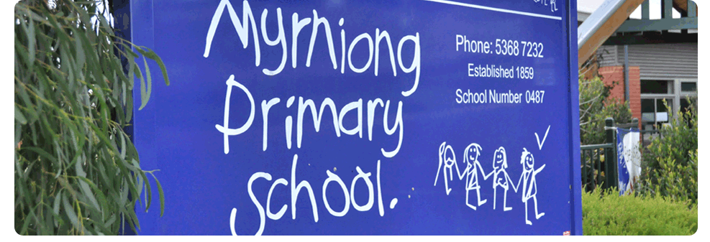
Working With Children Checks

POLICY 2017

MYRNIONG PRIMARY SCHOOL

Rationale:
The Working with Children Checks policy assists Myrniong Primary School in the protection of our students and maintains a safe environment by ensuring any person engaged in child‐related work (paid or unpaid) is compliant with the Working With Children Act 2005.

Aims:
• To ensure Myrniong Primary School is compliant with the Working with Children Act 2005.
• To ensure volunteers, employees and visitors working at Myrniong Primary School who fall within the guidelines determined by the Working with Children Act are compliant with the Act.

Guidelines:
• The Department of Education and School Councils have legislative obligations under the Act with respect to ensuring certain volunteers and employees have applied for, and receive a WWC Check.
• WWC Checks are valid for five years and are transferable between jobs or volunteer organisations.

Compulsory WWC Checks
• All School Service Officer (SSO) staff employed at Myrniong Primary School
• Parents and volunteers engaging in work as a volunteer in which their child does not participate
• Parents and volunteers who coach and/or support sports teams in which their child does not participate
• Parents and volunteers attending school camps
• Religious Education Instructors
• Any casual or short term staff employed by Myrniong Primary School or School Council (e.g. staff employed to assist with the Production or other special activities)
• Myrniong Out of School Hours (OSHC) staff
• Other volunteers engaged in child‐related work either paid or unpaid
• Student Support Service staff

Exemptions
• Principal Class and Teacher Class employees who are registered teachers under the Victorian Institute of Teaching (VIT) Act 2001 employed at GPS, as they have undergone criminal records checks through the VIT.
• A parent engaging in work as a volunteer in relation to an activity in which their child is participating or ordinarily participates is exempt in relation to that activity only.
• Tradespersons/cleaners who do not have ‘Direct Contact’ with students or are involved in ‘Child‐Related Work’.

Implementation:
• The school will make available application forms for volunteers wishing to apply for a WWC Check.
• At the start of each year, this policy will be communicated to the school community through the newsletter at the beginning of the year.
• The school will keep a register listing the relevant details of those people who have obtained a WWC Check so that it will not be necessary to produce the Check on every occasion. This register will be maintained by the Business Manager.
• The register will be updated with new WWC checks on an ongoing basis. At the start of every year the register will be updated and all WWC checks will be checked against the Department’s Central Register for continued suitability. This will be done by the business manager.
• All staff are required to be registered with the Victorian Institute of Teaching (VIT) and are therefore exempt from requiring a Working With Children Check as registration requires this check.
• Any person registered with the VIT seeking casual or contract employment must provide a copy of a current registration before commencing. Employment agencies used by the school require the same for Casual Relief Teaching.
• Sufficient time will be given for volunteers attending camps to obtain a WWC Check.
• All employees and volunteers of Myrniong Primary School are responsible for acquiring and maintaining current WWC Checks.
• Reimbursement of fees incurred by individuals will be at the discretion of the Principal.
• Regular and systematic checks will be conducted by the School Business Manager and authorised staff as appointed by the Principal.

Evaluation:
This policy will be reviewed as part of the school’s three-year review cycle.

This policy was last ratified by school council in:

