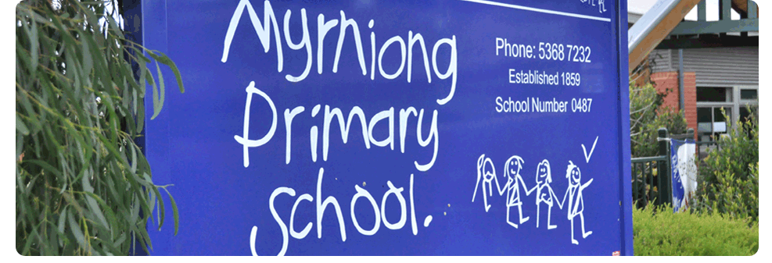
VISITORS POLICY
POLICY – 2017

MYRNIONG PRIMARY SCHOOL

Rationale
Myrniong Primary School seeks to provide an open and friendly learning environment which values and encourages visitors to our school. At the same time it is the responsibility to ensure the safety of all students and staff and it is essential that there are procedures in place to ensure the school knows who is on the premises at any time and these people are immediately recognisable for the safety of our students, staff and the visitors themselves.

Implementation
Visitors are defined as all people other than staff members, students and parent/guardians involved in the task of delivering or collecting students at the start or at the end of the school day.
All visitors will be required to report to the main office where they will be required to sign a ‘Visitors Book’ and will be assigned a badge, at the end of their visit to return the badge and sign out in the ‘Visitors Book’.
Visitors within the school who fail to follow this process will be reminded.

Parent Helpers
Many parents assist and support classroom/learning programs and these parents are often in the school for a short period of time but for safety reasons we do need a sign in via the front office. All classroom helpers must have a working with children check card which is photocopied and kept at the office.

Assemblies
For school assemblies visitors are requested to move to the assembly area and do not have to sign on or off, but must do so if they choose to remain in the school after assembly.

Special Events
On these occasions visitors are not required to sign in or out provided we can identify themselves as been connected to our students.

Afternoon Pick-Up
Parents do not need to go to the office if picking their children up from school at the end of the day, unless they are picking their child up early.
In this case they must pick report to the office and sign out early dismissal in the Student Sign Out Book

Excursions
All parents accompanying students on excursions require a working with children’s check.

Further Procedures
There may be occasions when parents wish to communicate with their child’s teacher and a time before or after school would be best.
If more time is needed then it is best to make an appointment to visit at a mutually convenient time.
If any issues arise that cause you or your child concern, please ring the school and we can follow up the matter.

Emergency Management
The schools Emergency Management Procedures will ensure that visitors within the school at the time of the emergency or practice drills will be recognised and appropriately catered for.
Staff and students should be aware of the schools visitor’s policy and should direct all visitors to the school office if they do not have a visitors pass.

REFERENCE

- The guidelines may be accessed through the Victorian Government Schools Reference Guide at: Section 4.16 – Visitors to schools
http://www.education.vic.gov.au/management/governance/referenceguide/enviro/default.htm

The visitors Policy will be published on the school newsletter.

This Policy will be ratified by School Council on (Scheduled for November 14th)

