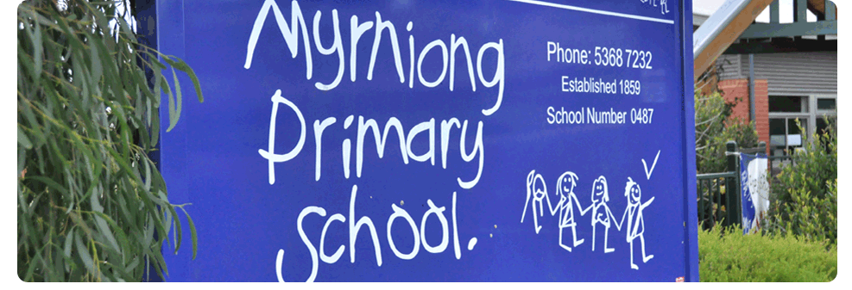
Student Engagement & Wellbeing

POLICY 2017

MYRNIONG PRIMARY SCHOOL

Rationale:
Our educators are a vital source of support and a determinant in the success of students. The teachers at Myrniong Primary School will work collaboratively to ensure that students feel valued, cared for and can effectively engage with their learning. Our school recognises the need to be engaging and inclusive, recognising and responding to the diverse needs of our students, accommodating different learning styles and rates of learning and early intervention when responding to students needs.
Our school strives to be a learning community where students and teachers can relate well to each other, and where different interest, ideas and viewpoints are valued, respected and encouraged. At M.P.S, we ensure that procedural fairness is followed at all times.
In any given class a range of student ability exists, in some cases spanning several years. Within this diversity, our school aims to challenge all students to become optimistic, resilient, creative and critical thinkers. We seek to promote our school values of Do your Best, Respect, Co-Operation, Resilience and Acceptance throughout the curriculum, in co-curricular activities, and in our daily operations.

Aims:
- Create a unique and student driven Developmental Curriculum
- Collaboratively develop and implement a fair and respectful whole-school behaviour management approach
- Encourage and provide multiple opportunities for parents/carers and members of the broader community to play an active part in the life of the school and the education of their children
- Promote active student participation and provide students with a sense of ownership of their environment
- Focus on establishing positive and respectful relationships between students, teachers and the community
- Identify and respond to individual students who require additional assistance and support

Implementation:

The curriculum programs of the school will recognise and respond to the diverse needs of the school’s students by:
- Accommodating different learning styles and rates of learning by implementing the Kathy Walker Developmental Curriculum in Foundation-2
- Intervening early to identify and respond to individual student needs
- Individual Learning Plans completed for all students identifying learning goals and progress throughout the year (template attached)

Myrniong Primary School is committed to the delivery of an inclusive curriculum that ensures all our students have access to a quality education to meet their diverse needs.
To improve educational outcomes for students with specific learning needs, the following key strategies are in place:
- Providing parents/carers with a learning program that best suits their child’s needs
- Involving students and parents in planning decisions through the development of the Individual Learning Pathways (ILP’s)
- Ensuring the expertise of teachers working in our school is maintained and developed
Myrniong Primary School will implement a whole-school behaviour management approach that is based on pro-social values, social competencies, incentives and positive peer relationships. (Refer to MPS, classroom, playground and Digital Technologies flow chart documents.)
The key focus will be on prevention and early intervention strategies that:
- Define and teach school-wide and classroom expectations
- Establish consistent school-wide and classroom consequences for problem behaviour
- Establish school-wide and classroom processes for early identification of students experiencing academic and/ or behaviour difficulty
- Provide school-wide and classroom processes for ongoing collection and use of data for decision-making
- Provide a physical environment conducive to positive behaviours and effective engagement in learning
- Utilise evidence-based interventions, monitored regularly for those students who face difficulty with learning and/or behaviour
Involvement in our school by parents and carers helps children achieve the best possible learning outcomes. Parents and carers will be provided with the opportunity to participate in school life, both formally and informally, through school council, volunteering and staying up to date with news about what is happening in education via our weekly newsletter, website and the FlexiBuzz app.

Implementing preventative and early intervention strategies to support positive behaviours is a key part of the Student Welfare process at our school. Prevention and early intervention strategies that the school will deploy include:
- Defining and teaching school-wide and classroom expectations
- Establishing consistent school-wide and classroom consequences for problem behaviour
- Utilising evidence-based interventions, monitored regularly for those students who face difficulty with learning and/or behaviour
- Establishing school-wide and classroom processes for early identification of students experiencing academic and/ or behaviour difficulty
- Providing school-wide and classroom processes for the ongoing collection and use of data for decision-making
- Providing a physical environment conducive to positive behaviours and effective engagement in learning
Myrniong Primary School will support families to engage in their child’s learning and build their capacity as active learners. It provides an environment that welcomes all parents/carers and is responsive to them as partners in learning.
The school will create successful partnerships with parents/carers and families by:
- Ensuring all parents/carers are aware of the school’s Student Engagement and wellbeing processes
- Involving families as participants in school decision-making
- Providing opportunities to enhance parenting knowledge and skills
- Conducting effective school-to-home and home-to-school communications
- Providing volunteer opportunities to enable parents/carers and students to contribute
- Involving families with homework and other curriculum-related activities
Myrniong Primary School will promote and maintain high levels of student attendance and participation through:
- Articulating high expectations to all members of the school community
- Adopting consistent, rigorous procedures to monitor and record student absences
- Following up student absences promptly and consistently
- Implementing data-driven attendance improvement strategies
- Creating safe, supportive learning environments where all students experience success through active participation and engagement in purposeful learning
- Providing early identification of, and supportive intervention for, students at risk of non-attendance
Myrniong Primary School will use coordinated early intervention and prevention strategies to identify and respond to individual students who require additional assistance and support. The school will provide the following support structures:
- Monitoring of, and responding to, protracted student absences
- Protocol for mandatory reporting
- Student Support Group’s for children in need
- Students with speech difficulties are identified and if needed are provided a speech program
Longitudinal data will be collected regarding frequency and types of welfare issues, so as to measure the success or otherwise of school-based strategies and approaches. Some sources of data are:
- The Attitudes to School Survey data
- Parent opinion survey data
- Data from case management work with students
Myrniong Primary School will use relevant external student wellbeing support services in order to identify and address the barriers that individual students face. Such services to provide support for students and staff include:
- Psychologist for psychological and academic assessment
- Department of Human Services case managers and support workers
- Speech therapist for children with speech difficulties
- Social workers to provide services such as counselling, social skills and anger management programs
- Relevant DET support staff

Evaluation:
This policy will be reviewed as part of the school’s three-year review cycle.
This policy is to be reviewed September, 2019

