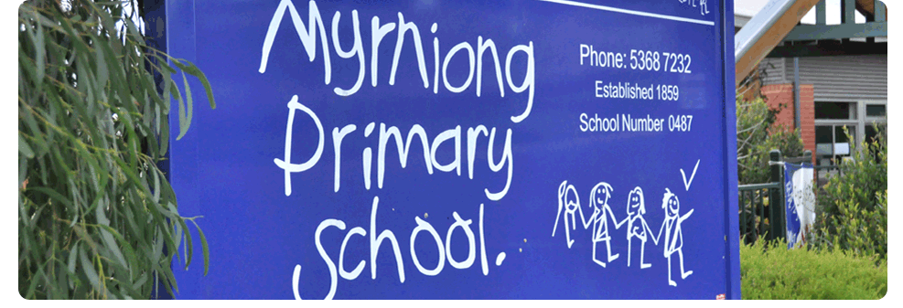
Code of Conduct

POLICY - 2019

MYRNIONG PRIMARY SCHOOL

FOR MEMBERS OF THE MYRNIONG PRIMARY SCHOOL COMMUNITY
RATIONALE
An engaged school community who share and support our school beliefs, values and endeavours is critical in enabling us to build and maintain a safe and effective school. Appropriate conduct by all school community members is central to ensuring we achieve this goal.
The purpose of this policy is to outline the responsibilities and expectations of all members of Myrniong Primary School community with respect to the way we behave, communicate and interact.

RESPONSIBILITIES
All staff, contractors, volunteers and any other member of the school community involved in child-related work are required to comply with the Code of Conduct by observing expectations for appropriate behaviour below. This Code of Conduct applies in all school situations, including school camps and in the use of digital technology and social media.

All members of the School Community are expected to:
- Conduct themselves in a respectful and responsible manner that recognises and respects the rights of others, promotes a climate of mutual respect and complies with the law.
- Communicate and interact with others in the school community in accordance with our school values: Cooperation, Respect, Acceptance, Resilience, Do Your Best.
- Comply with this Code of Conduct with respect to any school related communication or interaction.
School Leadership (principal and leading teacher or their nominees) is expected to:
- Lead the implementation and monitoring of this Code of Conduct and will plan, implement and monitor arrangements to provide inclusive, safe and orderly school and other learning environments.
- Model exemplary conduct by demonstrating the values held by our school.
- Communicate high expectations for the way in which staff, students, school community members and visitors conduct themselves.
- Provide a safe, secure and supportive learning environment.
- Advise parents, carers and other members of the community of the appropriate process for lodging a concern or complaint *(refer to school’s Parent Complaints Policy).
- Request any person acting in an offensive or disorderly way to leave the premises and if necessary, as an authorised person, direct them to do so.
- Call the police if a person fails to follow a direction to leave the premises.

Issue Resolution
  - Any member of the school community with a concern or complaint regarding the conduct of the principal have the options of expressing the concern or complaint directly to the principal or contacting the Regional Office for DET (Department of Education and Training).

Teachers and other Staff are expected to:
- Model appropriate behaviour in all contexts as a staff member of Myrniong Primary School.
- Work in partnership with parents and carers to enhance the learning outcomes and support the wellbeing and conduct of their students.
- Work with other staff and parents to help create and maintain a safe, secure and respectful learning environment for all students.
- Communicate to both parents and students high expectations for the learning achievement and conduct of all students.
- Ensure consistency and fairness in interactions with all members of the school community.
- Report all incidents of suspected abuse, bullying, harassment or violent conduct in line with DET policy.

Issue Resolution
  - Staff members with a concern or complaint regarding the conduct of any member of the school community should contact the principal.

All Parents and Caregivers are expected to:
- Support school staff in maintaining a safe, secure and respectful learning environment for all students.
- Work in partnership with the school to enhance the learning outcomes and support the wellbeing and conduct of their child/ren.
- Contribute positively to behaviour, academic or other personalised support plans that relate to their child.
- Act appropriately on the school premises and at any associated school events (e.g., camps, excursions, sporting events).
- Be aware that threatening behaviour and harassment towards staff, students or other parents/care givers is unacceptable.
- Respect and comply with reasonable requests or directions of the principal or other members of the staff.
- Obey all pedestrian and road rules to help ensure that all members of the school community have the opportunity to travel to and from school safely.
- Maintain respectful and confidential behaviour when communicating on social media platforms with regard to school-related matters.

Issue Resolution
  - Parents with a concern or complaint relating to their child are encouraged to arrange a time to meet with their child/s classroom teacher. Should they feel the matter remains unresolved, they should arrange a time to meet with the principal or leading teacher.
  - Parents with a concern or complaint regarding the conduct of any member of the school community should contact the principal.
  - If the matter remains unresolved, the parent then has the option of contacting the Regional Office for DET (Department of Education and Training).

All Students are expected to behave in accordance with a Student Code of Conduct, which is based on our school values, those being:
- Respect
- Resilience
- Cooperation
- Acceptance
- Do Your Best
Issue Resolution
  - Speak to their classroom teacher, principal or leading teacher.
  - Speak to their parents who then are invited to arrange to speak with their child/’s classroom teacher, principal or leading teacher.
Supporting Documentation:
- Victorian Registration and Qualifications Authority – Child Safe Standards
http://www.vrqa.vic.gov.au/childsafe/Pages/default.html
- DET Mandatory Reporting Guidelines: http://www.education.vic.gov.au/school/principals/spag/safety/Pages/childprotection.aspx
- Myrniong Primary School Parent Complaint Policy
- Myrniong Primary School Student Health and Wellbeing Policy
- Myrniong Primary School Child Safe Policy
- Myrniong Primary School Student Code of Conduct

EVALUATION
This policy will be reviewed as part of the school’s three-year review cycle.

Policy Ratified February 2019

