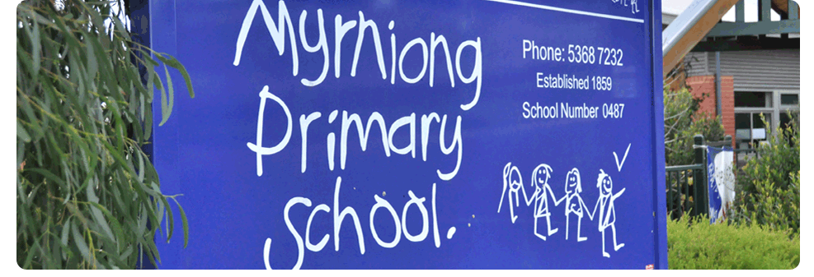
Duty Of Care

POLICY - 2021

MYRNIONG PRIMARY SCHOOL

Rationale:
In addition to their professional obligations, the staff at Myrniong Primary School have a legal duty to take reasonable steps to protect students in their charge from risks of injury that are reasonably foreseeable.

Aims:

- To ensure Myrniong Primary School staff have an understanding of their duty of care to students and other employees or volunteers, and behave in a manner that does not compromise these legal obligations.

Implementation:
- In addition to their professional obligations, staff have a legal duty to take reasonable steps to protect students in their charge from risks of injury that are reasonably foreseeable.
- Staff Duty of Care hours at Myrniong Primary School: 8:45am – 3:30pm
- Although the general duty is to take reasonable steps to protect students from reasonably foreseeable risks of injury, specific (but not exhaustive) requirements of the duty involve providing adequate supervision in the school or on school activities as well as providing safe and suitable buildings, grounds and equipment.
- The teacher’s duty of care is greater than that of the ordinary citizen in that a teacher is obliged to protect a student from reasonably foreseeable harm or to assist an injured student, while the ordinary citizen does not have a legal obligation to respond.
School staff have a duty of care in relation to students. Principals, teachers and other staff working with students must take reasonable steps to minimise the risk of reasonably foreseeable harm, including by:
- providing suitable and safe premises
- providing an adequate system of student supervision
- undertaking risk assessments for school activities and events
- implementing strategies to prevent reasonably foreseeable injuries, whether physical or psychological, to students (including injuries suffered as a result of bullying)
- ensuring that appropriate medical assistance is provided to a sick or injured student
- ensuring the school complies with the Child Safe Standards
- taking other reasonable precautions to minimise the risk of child abuse by an individual associated with the school
- implementing relevant Department and local school policies
- managing employee recruitment, conduct and performance
- Staff members are also cautioned against giving advice on matters that they are not professionally competent to give (negligent advice). Advice is to be limited to areas within a teacher’s own professional competence and given in situations arising from a role specified for them by the Principal.
- Teachers must ensure that the advice they give is correct and where appropriate, in line with the most recent available statements from institutions or employers. Teachers should not give advice in areas outside those related to their role where they may lack expertise.
External Providers
Staff at our school acknowledge that, as our duty of care is non-delegable, we are also required to take reasonable steps to reduce the risk of reasonably foreseeable harm when external providers have been engaged to plan for or conduct an activity involving our students. Our Visitors Policy and Camps and Excursions Policy include information on the safety and care of our students when engaged with external providers.

Classroom Duty of Care:
- Staff cannot leave the classroom during classroom activities and leave the supervision of students to a classroom volunteer or Pre-Service Teacher.
Before / After School – Duty of Care:
- A teacher’s duty of care is not confirmed to the geographic area of Myrniong Primary School or to school activities, or to activities occurring outside the school where a student is acting on a teacher’s instructions. The duty also applies to situations both before and after school where a teacher can be deemed to have ‘assumed’ the teacher-students relationship.
- Staff are to supervise students before school from 8:45am – 9:00am in the classroom and from 3:15pm – 3:30pm after school if required.
Yard Duty – Duty of Care:
- All staff are to arrive to every rostered Yard Duty on time.
- Staff are to have up-to-date Level 2 First Aid accreditation.
- Staff are to follow the Myrniong Playground Policy at all times when supervising Yard Duty.
Evaluation:
- This policy will be reviewed as part of the school’s three-year review cycle.

