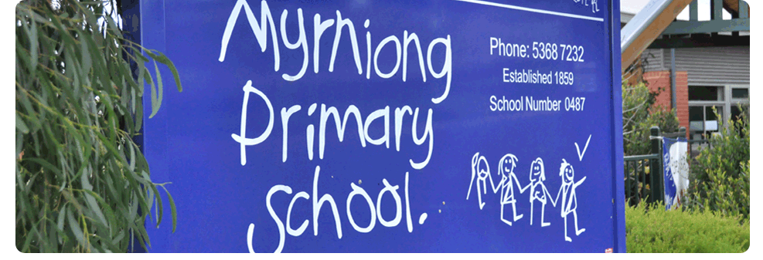
VISITORS POLICY
POLICY – 2021

MYRNIONG PRIMARY SCHOOL

Purpose
To provide a safe and secure learning and teaching environment for students and staff by establishing processes to monitor and manage visitors to Myrniong Primary School.
To establish protocols and procedures that effectively monitor and manage visitors without compromising the open and inclusive nature of the school.

Scope
This policy applies to any visitors who may attend school grounds when the school is open for instruction between the hours of 8:am to 4:30pm Monday to Friday and when the office is staffed to monitor/receive visitors at reception]. Outside of these times, our front office is not staffed and the only visitors who are permitted on school grounds are parents/carers or their delegates who are dropping off or picking up students from [Outside School Hours Care, school events such as parent teacher interviews, concerts, sport or other school activities, and community and other groups who have entered into contracts or agreements with the school to use school premises outside of school hours.

DEFINITIONs
Child-related work: As defined by the Worker Screening Act 2020 (Vic), child-related work is work that usually involves direct contact (including in person, over the phone, written and online communication) with a child that is a central part of that person’s duties. It does not include work that involves occasional contact with children that is incidental to the work.

Policy
Myrniong Primary School strives to create an open and inclusive school community, and encourages parents and carers to be actively involved in their child’s development and education. We also strive to foster strong partnerships with local community services, schools and other organisations.
Myrniong Primary School is not a public place. The principal has the authority to permit or deny entry to school grounds, and encourages all visitors to familiarise themselves with our school’s Statement of Values, Child Safe Policy, Statement of Commitment to Child Safety, Child Safe Code of Conduct.
From time to time, different members of the public may visit our school. Visitors may include, but are not limited to:
- Parents
- Volunteers – see our school’s Volunteers Policy for more information
- Prospective parents, students and employees
- Invited speakers, sessional instructors and others addressing learning and development
- Public officials (e.g. Members of Parliament, local councillors)
- Persons conducting business : uniform suppliers, booksellers, official school photographers, commercial salespeople
- Tradespeople
- Children’s services agencies
- Talent scouts
- Department of Health and Human Services workers
- Victoria Police
- Persons authorised to enter school premises (e.g. Worksafe inspectors, health officers etc.)
- Other Department of Education and Training staff (including allied health staff) or contractors
- NDIS therapists or other allied health or health practitioners

Sign in procedure
All visitors to Myrniong Primary School are required to report to the administrative office upon arrival prior to undertaking an activity within the school. They are required to sign a Visitors Book on arrival and completion of their visit. Contractors will be assigned a ‘Visitors’ badge which they must wear at all times within the school and, at the end of their visit, are required to return their badge and sign out in the Visitors Book.(see exceptions below in relation to parents/carers). Visitors must:
- Record their name, signature, date and time of visit and purpose of visit in the visitors’ book
- Provide proof of identification to office staff upon request
- Produce their valid Working with Children Check where required by this policy (see below)
- Wear a visitor’s [lanyard/name tag] at all times
- Follow instruction from school staff and abide by all relevant policies relating to appropriate conduct on school grounds including [insert relevant policies eg: Child Safety Code of Conduct, Sexual Harassment Policy, Workplace Bullying Policy, Respect for School Staff, Statement of Values etc]
- Return to the office upon departure, sign out and return visitor’s lanyard

This process will be published in school communications and will be displayed at all school entrances.
All visitors are required to comply with the schools Statement of Values.
Visitors who fail to follow directions will be directed to the Administrations Office.
The school’s emergency management procedures will ensure that visitors within the school at the time of any emergency or practice drill will be recognised and be appropriately catered for.
Myrniong Primary School will ensure that our school’s Child Safety Code of Conduct/Child Safety Statement of Commitment are available and visible to visitors when they sign in.
Requirements for visitors to produce a valid Working with Children Check card
All visitors who are engaged in child-related work (see definition above) must have a valid WWC Check.
In some circumstances, visitors to Myrniong Primary School who are not engaged in child-related work will also be required to produce a valid WWC Check depending on the particular circumstances of their visit. For example, Myrniong Primary School will require a valid WWC Check for:
- visitors who will be working regularly with children during the time they are visiting, even though direct contact with children is not a central part of their normal duties
- visitors (e.g. contractors), who will regularly be performing work at the school and in circumstances where they will be performing their work in an area where they will be unsupervised and around children.

Further background checks, including references, may also be requested at the discretion of the principal.
Visitors who will be working in areas away from students (e.g. a visiting auditor who will be located in the front office with administration staff) or who will be supervised and accompanied by a staff member during their visit (e.g. a Member of Parliament, a journalist, a prospective parent on a school tour) will not be required to have a WWC Check.
Sworn Victoria Police officers or sworn Australian Federal Police officers are exempt from requiring a WWC Check, but may be asked to verify that they are sworn officers by providing proof of identification.

Invited speakers and presenters
On occasion, Myrniong Primary School may invite external speakers or providers to deliver incursions, presentations, workshops and special programs for our students. Consistent with Department of Education and Training requirements, Myrniong Primary School will:
- ensure that the content of presentations and programs by external providers contributes to the educational development of our students and is consistent with curriculum objectives
- ensure that any proposed visit, programs or content delivered by visitors complies with the requirement that education in Victorian government schools is secular and is consistent with the values of public education, Department policies and the Education and Training Reform Act 2006 (Vic). In particular, programs delivered by visitors are to be delivered in a manner that supports and promotes the principles and practice of Australian democracy including a commitment to:
  - elected government
  - the rule of law
  - equal rights for all before the law
  - freedom of religion, speech and association
  - the values of openness and tolerance
  - respect the range of views held by students and their families.

Parent visitors
We understand that there may occasionally be a reason why a parent or carer may want to speak to or see their child at school, during school hours.
If there is a particular pressing or unavoidable issue that cannot wait until the end of the school day, we ask that parents or carers call the school office to make the request to speak to or see their child during school hours.
We also ask that parents avoid arranging to visit their children at school wherever possible, as this can cause inappropriate disruptions to the school day.
All parents or carers who visit our school during school hours, other than for the purposes of school pick ups and drop offs or for specific school events (eg parent teacher interviews, concerts, assemblies etc), are required to sign in as a visitor at the school office.

Other visitors
All business operators, tradespeople and other visitors attending the school to conduct work must report to the school office upon arrival for instruction and follow the sign in procedure outlined above.

COMMUNICATION
This policy will be communicated to our school community in the following ways:
- Included in staff induction processes
- Discussed at staff briefings or meetings, as required
- Included as annual reference in school newsletter
- Made available in hard copy from school administration upon request

Related policies and resources
Related school policies:
- Statement of Values, Volunteers Policy
- Child Safety policy
- Child Safety Code of Conduct
- Volunteers

POLICY REVIEW AND APPROVAL
School council consulted | 13/07/2021
Policy last reviewed | 13/07/2021
Next scheduled review date | May 2024

