Myrniong Primary School
Enrolment Booklet

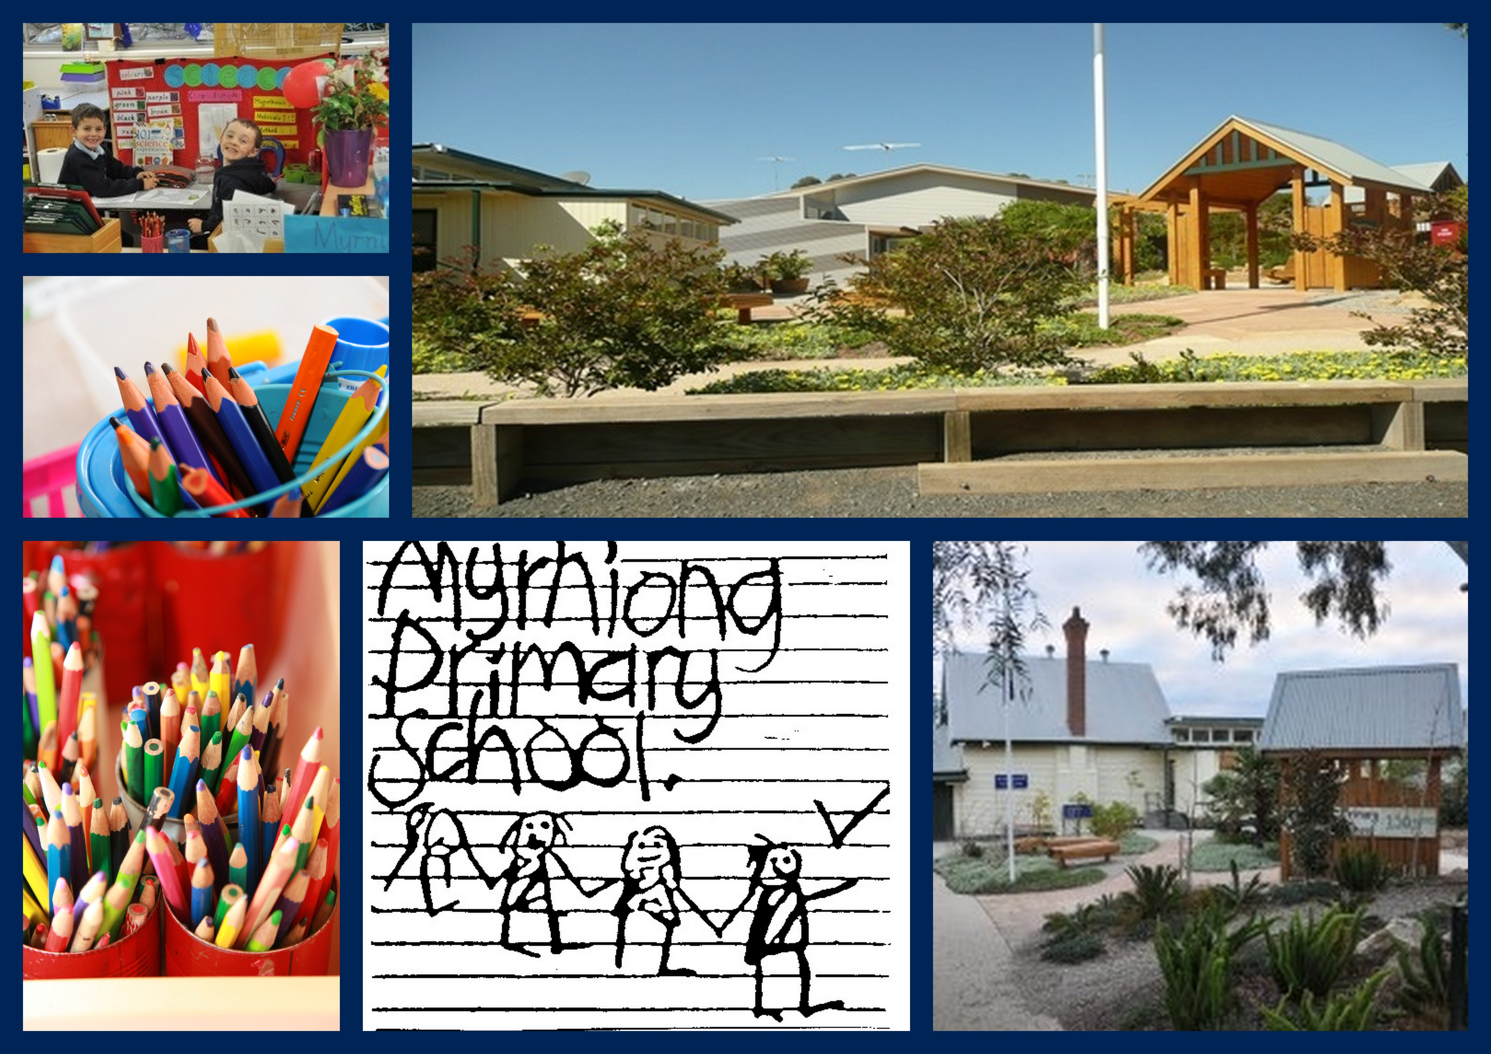

PRINCIPAL’S MESSAGE

Dear Parents and Children,
Welcome to our school, Myrniong Primary School. Myrniong Primary School’s motto "Facing the Future Together" emphasises the strong partnership between our school and its community. Together we begin a journey as partners in education. We aim to provide a safe, secure and caring atmosphere where every child is valued, respected and able to learn, grow and play in a wonderful environment.

Our caring, dedicated and enthusiastic teachers implement a comprehensive curriculum filled with interest, variety and challenge. Our curriculum is based on the Victorian Curriculum domains English, Mathematics, STEM, Information and Communication Technology, Health and Physical Education, Interpersonal Learning, Personal Learning, Civics and Citizenship, The Arts and L.O.T.E. (Japanese), Communication and Critical & Creative Thinking. We also provide specialised support programs for students at risk, and an Enhanced Learning Program. Teachers ensure that individual student’s learning styles are catered for, providing differentiated teaching programs and Individual Education Plans. Special days, camps, excursions and multi-aged group activities enhance and expand our comprehensive curriculum. All students are encouraged to become independent learners, leaders, and risk takers in searching for and acquiring skills, knowledge and understandings.
Our school has a fair, equitable and consistent Code of Conduct, which builds on community and family values of Respect, Co-operation, Acceptance, Resilience, and Doing our best.
Our school believes, together in partnership, we go forward building a positive and enthusiastic attitude towards students’ learning.
Myrniong Primary School has so much to offer. The only way to appreciate and experience our school is to visit. So I invite you to contact us to discuss the opportunity to find out more.

David Garner
PRINCIPAL

HISTORY OF THE SCHOOL

Myrniong Primary School is among this State’s oldest, most enduring schools. Since its establishment over 150 years ago, on 1st October 1859, the school has served the local community and surrounding districts under a variety of official names.
Located in an area called Blow’s Flat, the following names have applied:-
1854 Pentland Hills National School
1863 Myrniong Common School No. 487
1873 Myrniong State School No. 487
1970 Myrniong Primary School No. 487
Within the original building of handmade bricks, red pine walls, baltic pine flooring overhung by a shingle roof, books were few, slates were scarce and expensive. The rest of the school’s equipment comprised of little more than an easel, blackboard or two, together with a few primitive maps and charts. These were displayed before an overcrowded classroom of pupils uncomfortably perched on long backless desks that were the vogue of the nineteenth century.

Today our school’s main building comprises the staff room, meeting room, staff/disabled toilet, principal’s office, first aid room, foyer and administration area.
Our state of the art learning area comprises 8 classrooms, a shared open learning area and a fully equipped library. Our computer facilities are leading edge, with an interactive whiteboard in all classrooms, and an extensive 1:1 iPad program.

Our school site is in a unique country setting with a magnificent view of Mount Blackwood and the surrounding range. The picturesque grounds provide an engaging Environmental Science learning area including a tall ship, vegetable patch, chook shed, water saving, composting and waste systems and an Indigenous garden. The attractive grounds include a smart grass oval, adventure playground, wet weather shelter, shaded areas, sealed games area, student / staff /disabled toilets and disabled access to all buildings. The Outside School Hours Care is provided on the school site.

An enhancement to our facilities is the multipurpose shed as well as our upgraded playgrounds with permanent shade cover.

SCHOOL ADMINISTRATION

ENROLMENTS
The Department of Education and Training regulations require that certain documents relating to your child must be maintained at school. These are the child’s Birth Certificate and Immunisation Record.

PARENT PAYMENTS
Parent Payment Charges are approximately $200 per child which covers the following:
- Literacy and Numeracy Resources &
- Classroom Requisites (e.g. exercise books)
**Please note these are subject to change each year pending department guidelines and budgets.

Voluntary Levy – At own discretion.

SCHOOL SUPPORT SERVICES
A Speech Pathologist and an Educational Psychologist are available for student referrals. Any issues that you may have with regard to your child’s educational progress should be discussed with the class teacher in order for appropriate action to be taken.

MEDICAL INFORMATION
For the safety of your child, it is imperative you inform your child’s classroom teacher of any prescribed or non-prescribed medications and any other medical conditions. Any medication to be taken at school must be handed to the teacher, along with a note giving the teacher authority to administer the medicine, stating:
- Student’s name
- Name of the medication to be administered
- Dosage required
- The frequency
- Permission

UNIFORM
Myrniong Primary School believes that a student dress code will encourage a sense of individual and collective pride in students and their identification with the school. In addition, it has the potential to promote group security and enhance the safety of individual students. School uniform is compulsory and must be worn by all students while at school and on school related excursions. Students are expected to have varnish free nails and to adhere to the safety requirement which permits the wearing of studs only in the ears.
A full uniform list is available from the office and the uniform is purchased from the school.
Please note parents may seek exemption from wearing the uniform on religious or disability grounds only. A request must be made to the principal in writing. The school welcomes parental feedback on uniform.
The compulsory uniform consists of:
- The navy school slouch hat (compulsory from September 1st to 30th April), but also encouraged to be worn throughout the year
- Navy school windcheater, hoodie or bomber jacket (with logo)
- Sky blue polo shirts (with logo)
- Navy winter track pants
- Navy summer shorts
- Blue/white check summer dress
- Black shoes
- Hair accessories in school colors only
*It is important that all uniform items are clearly named and checked regularly as names often wash out.

LOST PROPERTY
The Lost Property basket is located in the Office building. Named items are returned to children regularly. This basket holds a range of unnamed items. Please feel comfortable going through this basket when one of your child’s items has gone missing.

SCHOOL PHOTOGRAPHS
Each year all children are photographed individually and in their class groups. Family groups can also be arranged. Parents are given plenty of warning to ensure children look their best on this special day.

BRINGING MONEY TO SCHOOL

When children bring money for school purposes (levies, excursions etc.) please put it in an envelope with the necessary information on the outside - child’s full name, class, purpose and amount. Money to be spent at the canteen during recess or lunchtime should be put in a small purse with the child’s name clearly marked.
The school has payment envelopes should parents wish to use them. These can be collected from the Office.

CAMPS SPORTS EXCURSION FUND
This is a Government allowance payable to all parents who hold a current Health Care Card or Pension Card and have children attending our school. Students must be enrolled on the first day of school and cards must be valid on that day as well.

CONVEYANCE ALLOWANCE
A travel allowance is available from the Government to families who take their child(ren) to school by car daily. The following criteria must be met:
- Travel more than 4.8 kms one way to Myrniong P.S.
- The current bus route is unavailable to you
- You do not pass another Primary School to attend Myrniong P.S

CANTEEN
The school canteen is run (under strict supervision) by the Junior School Council. The canteen provides snacks and icy poles on a Wed/Thurs/Fri.

LUNCHES
A pie warmer facility is provided all year to enable children to heat lunches. Please ensure food is wrapped in foil and clearly labelled with the child’s name. Pie warmers are distributed to students at 1:30pm by staff members. These cannot be plastic containers, and cannot be in containers any taller than 3cm in height.

GENERAL INFORMATION
School Address:
Myrniong Primary School
Address : 13 Muddy Lane
Myrniong 3341
School Number 0487
Ph: 5368 7232
Email: myrniong.ps@education.vic.gov.au
Website: www.myrniongps.vic.edu.au
Business Manager: Karen Konieczny
School Council President Ainsley Bellette

TERM DATES
Refer to the www.education.vic.gov.au website for a list of Term dates for each year and public holidays.

PUBLIC HOLIDAYS
In line with DET guidelines, the school observes the following public holidays – Labour Day, Good Friday, Easter Monday, Anzac Day, Queen’s Birthday, and Melbourne Cup Day.

BELL TIMES
9:00am School starts
11:00am - 11:30am Morning recess
1:30pm - 1:45pm Lunch in classroom
1:45pm – 2:15pm Lunch recess
3:15pm School dismissal
3 minutes of Music precedes the bell so children return to class on time.
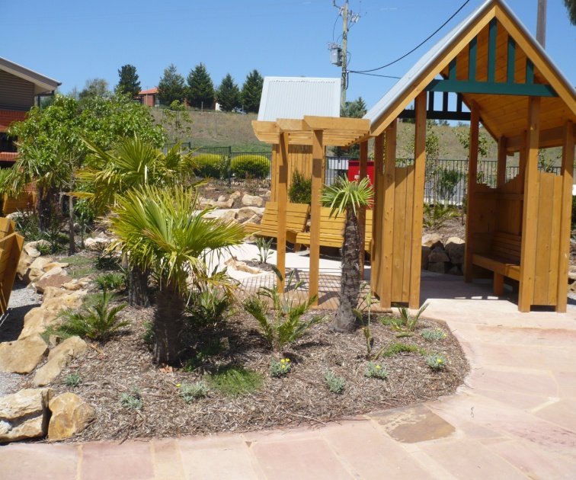
SCHOOL PROCEDURES

PUNCTUALITY
Classroom sessions begin at 9:00am each day. As students may need to undertake routines such as pie warmers, housing of bags and changing of take home books, it is recommended that they arrive at school in plenty of time to complete these tasks.
Please ensure your child is at school by 8:55am as the first five minutes of class time each day are most important. This is when the day's routines are outlined. Students who arrive late for school prevent the class from having a smooth start by interrupting the classroom program.

STUDENT SUPERVISION
During all recess breaks, and for fifteen minutes before and after school, there are teachers on yard duty in the playground. If it is too wet, windy or hot for the students to play outside during recesses, yard duty teachers supervise students in classrooms.
Students are not permitted to be in classrooms when a teacher is not in attendance. Students should not be in the school grounds before 8:45am when teacher supervision begins or after 3:30pm when supervision ends. Please deliver and collect your children between the above times.
Parents are requested to make full use of the Out of School Hours Program. Students can be booked in for before or after school care and enjoy fully supervised activities.

ABSENCE DURING SCHOOL HOURS
Sometimes it may be necessary for parents to collect students early. On such occasions advance notice is appreciated and arrangements must be made for the collection of the students from school. Prior to the student being collected from the classroom, parents must complete the student sign in / out book, located at the Office.

BEHAVIOUR AND WELLBEING
At Myrniong Primary School we respect diversity within our school community. Our school values are Respect, Co-operation, Acceptance, Resilience and Doing Our Best. At our school, we aim to provide a supportive learning environment through the implementation of a consistent approach to student welfare. The emphasis is on reinforcing and fostering positive student behavior.
The Student Engagement and Wellbeing guidelines and the Community Values and Bullying statements aim to foster respect and understanding and to develop a safe and happy environment for all members of the school community. It reflects student, staff and parent rights and responsibilities.

VISITORS TO SCHOOL
All visitors must report to the Office and sign the visitors book upon entering the school grounds. Any family members that wish to provide assistance and support in the classroom must have a working with children check.
http://www.workingwithchildren.vic.gov.au

APPOINTMENTS
At Myrniong Primary School we are proud of our “open door” policy. If you have any concerns that you would like to discuss, please contact the school (Phone 5368 7232) so that an interview can be arranged at a mutually convenient time.

OUT OF SCHOOL HOURS CARE
Out of Hours Care Program operates every weekday from 6:30 – 8:45 am and 3:15 – 6:30 pm.
To use this facility, children must have an up-to-date enrolment form. It is a good idea to register even if you may only require occasional care. For care availability on Pupil Free Days, please speak to the co-ordinator. Enrolment forms for the program are available from the Centre or at the school Office. Session fees are available from the Office. *Late fees exist for pick-up after 6:30PM
Bookings:
Co-ordinator: Ms Kady Stan
Email: oshc.myrniong.ps@education.vic.gov.au
Phone 5368 7027 between 6:30am – 9:00am
3:15pm – 6:30pm
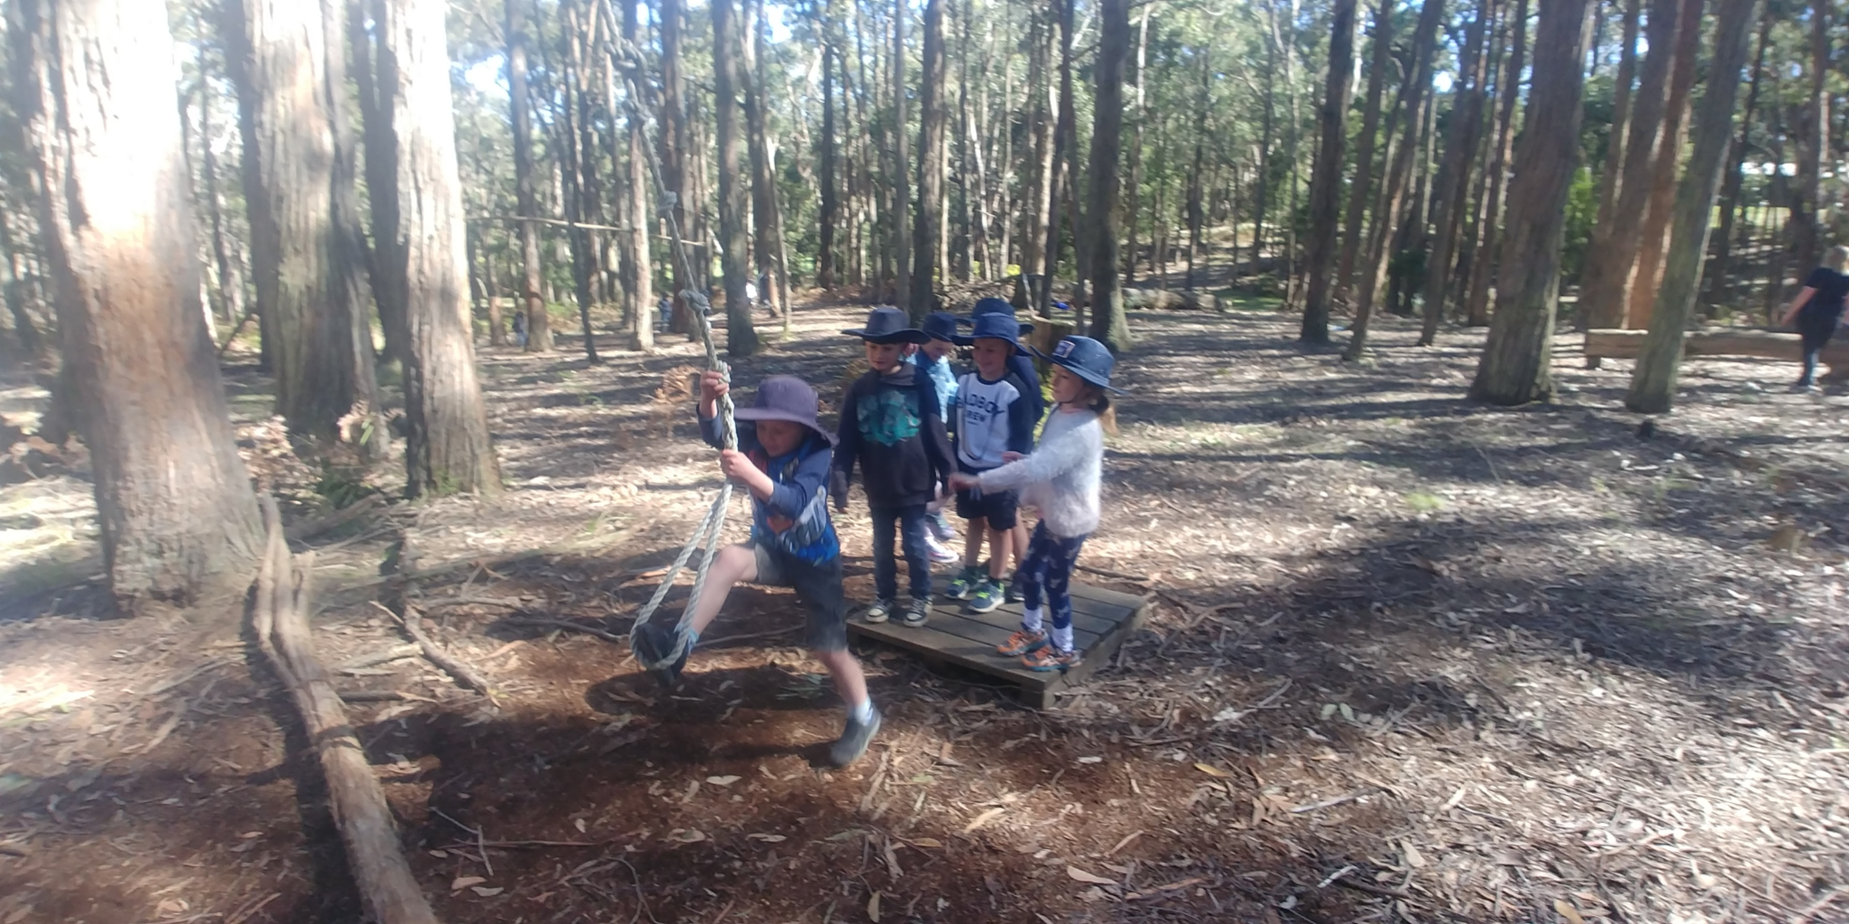

XUNO
We communicate vital information and celebrations to parents via XUNO, which can be accessed via the App or website. Messages, notifications and photographs are all sent to your mobile phone for your convenience.

ASSEMBLY
Each Thursday afternoon an assembly is held for all the school at 2:40PM. Parents, family and special friends are welcome to attend. Each class presents an item on a rotating basis. Our Assemblies are run by our school captain and vice captains.

NEWSLETTER
Newsletters are emailed home each fortnight as well
as put onto Xuno.
It is an important communication, which gives details of events and activities within the school. Parents are also encouraged to use the Newsletter for advertising as required. It is important that parents take the time to read through the Newsletter with their children.

PARENT/TEACHER/STUDENT INTERVIEWS
Each year, parent teacher interviews are scheduled across Semester 1 & 2. Parents are notified at the beginning of each year as to the interview schedule for the year. Bookings are made online via XUNO.

REPORTING TO PARENTS
As mentioned previously, early in the school year parents are able to meet with staff and discuss any matters relevant to their child's schooling for that year.
Parent-teacher-student interviews are held each semester (Term 1 and Term 3). Written reports are completed midyear and at the end of year. Students in Years 3 and 5 will receive a National Assessment Program – Literacy and Numeracy (NAPLAN) report following the assessments held each year. The purpose of reports and interviews is to share information regarding your child's progress.
Parents are welcome to discuss any matters relating to their child's education. An appointment needs to be made at a mutually convenient time to discuss areas of concern.

CURRICULUM & REPORTING DAYS
Schools are allocated a number of child free days per year for curriculum development and reporting and assessment. On these days the school will be closed for students. Advance notice will be given of these closures.

SCHOOL COUNCIL
The School Council is the focal point for school decision-making. School Council responsibilities include areas such as curriculum, finance, facilities and school-community relationship. The Council consists of parent representatives, teachers, the Principal and co-opted members. School Council meetings are held once a month and all parents are invited to attend but only elected members have voting rights. The School Council offers the opportunity for parents to take part in the educational decision making at the school level.

STUDENT LEADERSHIP
Junior School Council is made up of representatives from each year level F - 6, elected by their peers. These students are led by two Year 6 School Captains and two Year 6 Vice Captains. Junior School Councillors meet regularly and have input as to how their fundraising monies are spent, provide feedback to the Principal on ideas for the school and offer student voice into other school operations.
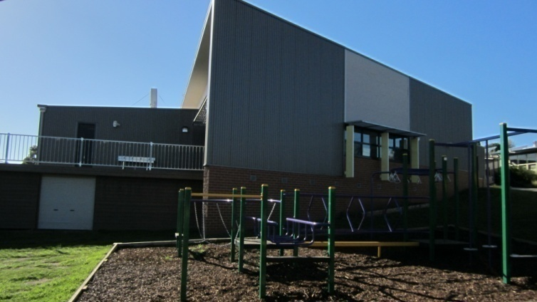
CURRICULUM
INFORMATION NIGHTS
During the year curriculum information evenings may be held. These events are family occasions and the emphasis is on strengthening the educational partnership between teachers, parents and students.

ICT & B.Y.O.D PROGRAM
Information and Communication Technology (ICT) is integrated into all areas of the curriculum. All junior classrooms have access to iPads and computers and a range of tools including Interactive Whiteboards.
In Grades 2-6 we offer a Bring Your Own Device (BYOD) program, where students can bring their own iPad. Parents will be informed of which Applications need to be installed onto their child’s device. Teachers have undertaken extensive Professional Learning in this area and are very aware of their responsibility to ensure children are educated appropriately in using ICT.

SWIMMING
An intensive swimming program is offered to all students in Foundation to Year 6. Fully qualified Auswim instructors conduct the swimming lessons. Children are placed into ability groups and learn swimming and survival skills.

INSTRUMENTAL MUSIC TUITION
Tuition from private music teachers is available for keyboard, guitar and drums. Application forms are available at the Office.

JUNIOR ENROLMENT CURRICULUM
FOUNDATION (PREP) INTERVIEW
All Foundation students will undertake an individual Foundation Entry Assessment. Each child will have an appointment to allow this assessment to take place.

FOUNDATION BUDDY PROGRAM
Each Foundation child is matched to a Year 6 buddy during the transition program prior to the year of entry. Buddies ease the transition from kindergarten to school by providing a special older friend in the playground. The program aims to develop confidence, promote leadership skills and foster a learning environment built on trust and
co-operation.

SCHOOL MEDICAL SERVICE
A School Nurse makes annual visits to the school to examine Foundation students, and may see others referred by teachers or parents. The School Nurse will check your child’s sight, hearing, speech and gross and fine motor skills. The School Nurse also offers a parent information session prior to her examination of children. Parents are notified of a pending visit. Head Lice checks are held randomly and/or when needed.

SEESAW
At a classroom level, we utilise the Seesaw App / website for in-class, homework and remote learning tasks. It is essential all students and families have access to this at home.

